Ivan I.

IVANOV

IVANOV
Ivan I.
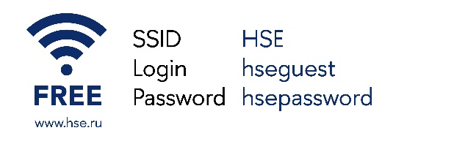
LIVE STREAMING NOW

